Atitit activemq 消息系统服务使用说总结

1.1. 启动 1

1.2. 打开管理界面（管理界面可以查看并管理所有队列及消息） 1

1.3. 代码写消息 读取消息参考范例项目 1

1.4. 范例项目 C:\0wkspc\MqDemoPrj 1

1.5. 范例代码 1

1.6. 参考资料 2

## 启动

>C:\apache-activemq-5.14.4\bin\activemq.bat start

root of context hierarchy

INFO | Using Persistence Adapter: KahaDBPersistenceAdapter[C:\apache-activemq-5.16.0\bin\..\data\kahadb]

INFO | PListStore:[C:\apache-activemq-5.16.0\bin\..\data\localhost\tmp_storage] started

INFO | Apache ActiveMQ 5.16.0 (localhost, ID:DESKTOP-LE76MSF-64411-1601455636626-0:1) is starting

INFO | Listening for connections at: tcp://DESKTOP-LE76MSF:61616?maximumConnections=1000&wireFormat.maxFrameSize=104857600

INFO | Connector openwire started

INFO | Listening for connections at: amqp://DESKTOP-LE76MSF:5672?maximumConnections=1000&wireFormat.maxFrameSize=104857600

INFO | Connector amqp started

INFO | Listening for connections at: stomp://DESKTOP-LE76MSF:61613?maximumConnections=1000&wireFormat.maxFrameSize=104857600

INFO | Connector stomp started

INFO | Listening for connections at: mqtt://DESKTOP-LE76MSF:1883?maximumConnections=1000&wireFormat.maxFrameSize=104857600

INFO | Connector mqtt started

INFO | Starting Jetty server

INFO | Creating Jetty connector

WARN | ServletContext@o.e.j.s.ServletContextHandler@386f0da3{/,null,STARTING} has uncovered http methods for path: /

INFO | Listening for connections at ws://DESKTOP-LE76MSF:61614?maximumConnections=1000&wireFormat.maxFrameSize=104857600

INFO | Connector ws started

INFO | Apache ActiveMQ 5.16.0 (localhost, ID:DESKTOP-LE76MSF-64411-1601455636626-0:1) started

INFO | For help or more information please see: http://activemq.apache.org

INFO | ActiveMQ WebConsole available at http://127.0.0.1:8161/

INFO | ActiveMQ Jolokia REST API available at http://127.0.0.1:8161/api/jolokia/

## 打开管理界面（管理界面可以查看并管理所有队列及消息）

<http://localhost:8161/>

Admin

Admin

## 代码写消息 读取消息参考范例项目

## 放入100消息后管理界面

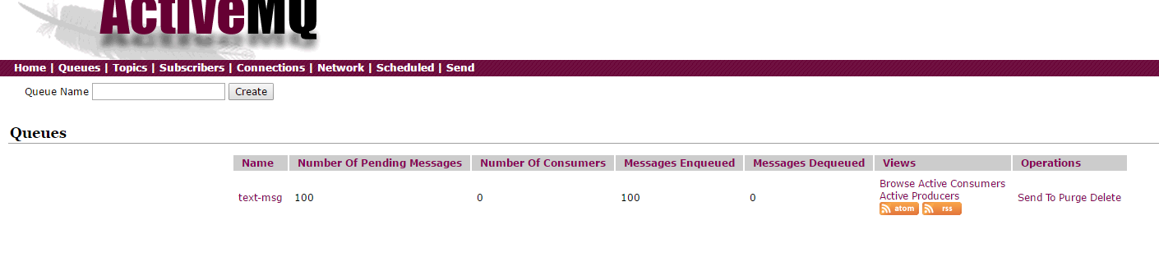

## 范例项目 C:\0wkspc\MqDemoPrj

## 范例代码

ActiveMQ消息队列的使用及应用 - 朱小杰 - 博客园.html 有代码片段 范例代码

## 参考资料

ActiveMQ消息队列的使用及应用 - 朱小杰 - 博客园.html

ActiveMQ的简单使用 - CSDN博客.html

ActiveMQ消息队列的使用及应用 - 朱小杰 - 博客园.html 有代码片段 范例代码